Internship Challenge 2020 – Arcurve Inc.

Snippet:

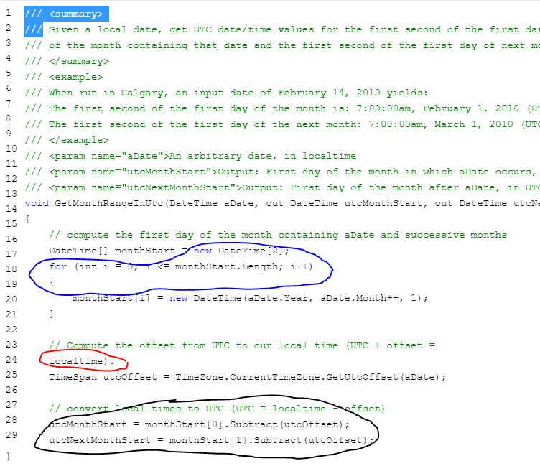

Blue: Initializing an array here probably works, and maybe could add some modularity for future implementations, such as getting the start time of the month after the next, or even after that.

For the given purpose, this could be done more efficiently (space and time-wise) by initializing monthStart as one datetime variable, converting to UTC, storing the utcMonthStart, updating incrementling monthstart’s month, and then copying the value into utcNextMonthStart.

What can be done:

DateTime monthStart = new DateTime(aDate.Year, aDate.Month, 1);

//writing the second monthStart variable can be done in the black section without an array or loop

Red: This is a syntax error because it is not a part of the comment above it. Delete or move it to the comment.

Black: Tied to blue, the program would be cleaner and would save more space if done by overwriting like this:

UtcMonthStart = monthStart.Subtract(utcOffset);

monthStart.setMonth(aDate.Month++);

utcNextMonthStart = monthStart.Subtract(utcOffset);